Yahtzee game

made in C#

By Mehlian

12/28/2017

Table of contents

1 Introduction 2

1.1 Overview 2

1.2 Goals 2

1.3 Scope 2

1.4 Definitions 2

2 General Design Constraints 2

2.1 Dice Game Application Environment 2

2.2 User Characteristics 2

3 Nonfunctional Requirements 2

3.1 User Interface 2

4 Functional Requirements 2

4.1 Game rules 2

4.2 USE CASE 4

**Revision History**

|  |  |  |  |
| --- | --- | --- | --- |
| **Version** | **Date** | **Name** | **Description** |
| 1 | 12/28/2017 | Mehlian | Initial Document |
|  |  |  |  |
|  |  |  |  |

# Introduction

## Overview

Yahtzee is a game for 2-4 players, where each player rolls a dice and based on roll results gains points. Yahtzee application will be a desktop app for Windows OS. The app will allow players to play Yahtzee game and save their score.

This document provides information on requirements for the Yahtzee software application.

## Goals and Objectives

Project’s goal is to provide users ability to play Yahtzee game in virtual environment.

## Scope

Application is designed with Windows OS platforms in mind that can use .NET Framework. Users will be able to play game at any time with ability to save scores.

## Definitions

Yahtzee Application – the product (software) that is being described in this document.

User – the person or persons who will interact with the Yahtzee application.

Use Case – description of goal – oriented interaction between the system and an actor. A use case may define several variants called scenarios that result in different paths through the use case and usually different outcomes.

Scenario – one path through a user case.

Actor – user or other software system that receives value from a user case.

Developer – the person or organization developing the system, also sometimes called the supplier.

# General Design Constraints

## Yahtzee Application Environment

Application is designed to work on a Windows OS platform using .Net Framework.

## User Characteristics

User in anyone that gain access to the application.

# Nonfunctional Requirements

## User Interface

Application is designed to work as WPF app. UI should inform users with game’s status.

Main window – welcome screen:

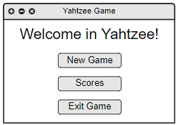

Main Window – number of players selection:

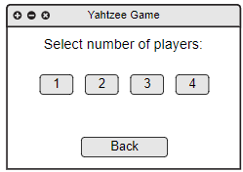

Main Window – player’s name input:

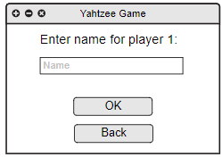

Game Window:

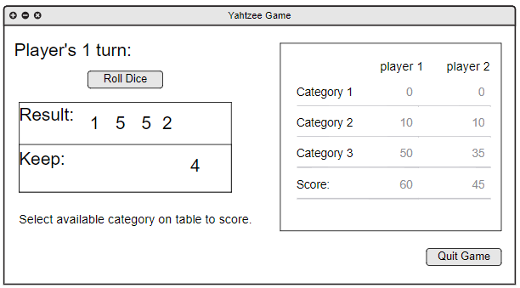

Scores Window:

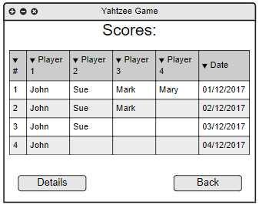

Scores Window – details panel:

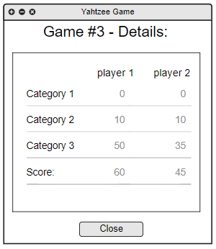

# Functional Requirements

## Game rules

**General rules:**

Game consists of thirteen queues, where every player can roll dices three times. At first for given turn, player rolls with all five dices, then on second and third dice roll, player can select which dices he wants to roll (second and third roll is optional).

After dice roll, player can select category to get points or exclude chosen dices in next roll. Once category is selected, points are saved and given category is no more available for this player.

All thirteen categories are shown in table below:

|  |  |  |  |  |  |
| --- | --- | --- | --- | --- | --- |
|  |  | **Player 1** | **Player 2** | **Player 3** | **Player 4** |
| **First** **Half** | Aces |  |  |  |  |
| Twos |  |  |  |  |
| Threes |  |  |  |  |
| Fours |  |  |  |  |
| Fives |  |  |  |  |
| Sixes |  |  |  |  |
|  | **SUM (Bonus)** |  |  |  |  |
| **Second Half** | 3 of a kind |  |  |  |  |
| 4 of a kind |  |  |  |  |
| Full house |  |  |  |  |
| Small straight |  |  |  |  |
| Large straight |  |  |  |  |
| Yahtzee |  |  |  |  |
| Chance |  |  |  |  |
|  | **SUM (Bonus)** |  |  |  |  |
| **RESULTS** |  |  |  |  |

**Score rules:**

In first half of the table (Aces, Twos, Threes, Fours, Fives, Sixes) score is determined by summing points of the similar dices.

Example: Player 1 rolls dices and gets this result: 2,2,3,6,6.

Here is his options:

|  |  |  |
| --- | --- | --- |
| **Category** | **Score** | **Description** |
| Twos | 4 | two dices with 2 points (2x2) |
| Threes | 3 | one dice with 3 points (1x3) |
| Sixes | 12 | two dices with 6 points (2x6) |
| Aces, Fours, Fives | 0 | zero dices for given category |

If sum of points for first half of the table gives 63 points or more, given player gets bonus 35 points.

In second half of the table score is determined based on given category:

* 3 of a kind – there are at least 3 dice of same kind; score is based on sum of all dice. Example: 2,3,4,4,4 gives 17 points.
* 4 of a kind – there are at least 4 dice of same kind; score is based on sum of all dice. Example: 4,5,5,5,5 gives 24 points.
* Full house – combination of three of one number and two of another; gives 25 points. Example: 2,2,5,5,5 gives 25 points.
* Small straight – four sequential dice; gives 30 points. Examples: 1,3,4,5,6 or 1,2,3,4,6 gives 30 points.
* Large straight – five sequential dice; gives 40 points. Examples: 1,2,3,4,5 or 2,3,4,5,6 gives 40 points.
* Yahtzee – all five dices are the same; gives 40 points. Example: 1,1,1,1,1 or 5,5,5,5,5 gives 50 points.
* Chance – score is based on sum of all dice. Example: 1,1,3,3,5 gives 13 points.

Every player can choose categories freely, but if conditions are not met he scores 0 points for given category.

**Extra rules:**

If player rolls “Yahtzee” more than one time, and in first half of the table suitable category is already taken, player can choose freely other categories from second half of the table and on top of that scores 100 bonus points.

Example: Player 1 has already taken “Threes” category and “Yahtzee” category, then rolls 3,3,3,3,3. Now he gets 100 points, can select freely category in second half of the table for scoring points based on that category, or if there is no more available categories he can select category in first half of the table to score 0 points.

**Ending:**

End of the game occurs when all categories are filled with points. Player with highest score wins.

## Required Features

**General Features:**

1. Ability to play Yahtzee game.
2. Support for 1 to 4 players.
3. Application provides table with game categories.
4. Application allows to roll dices.
5. Application saves scores when game is over.

**Additional Features:**

1. Player order is determined by order of name input.
2. Game scores are saved as xml files.

## Use case 1

**Description**

1. User starts application to play a game.

**Actors**

1. One or more users.

Steps of Execution (basic path)

1. User starts Yahtzee Application.
2. System displays welcome screen.
3. User clicks “New Game” button.
4. System asks for number of players.
5. User selects number of players by clicking on proper button.
6. System asks for players’ names.
7. User provides players’ names.
8. System provides clear table with categories to fill and asks player one to roll dice.
9. Active player rolls the dices.
10. System provides result of roll and displays available options for given player.
    1. Player select dices to keep and then roll remaining dices again (return to step 10; max 2 times).
    2. Player choses category to assign points based on roll results.
11. System assigns points and asks next player to roll the dices (return to step 9).
12. If all categories are filled for all players, System compares points and announce the winner.
13. System saves Game results.
14. System asks if players wants to play again.
    1. User selects Yes button (return to step 8).
    2. User selects No button (return to step 2).

Steps of Execution (alternate path)

1. User starts Yahtzee Application.
2. System displays welcome screen.
3. User clicks “Exit Game” button.
4. System exits.

## Use case 2

**Description**

1. User starts application to view score of past games.

**Actors**

1. One or more users.

Steps of Execution (basic path)

1. User starts Yahtzee Application.
2. System displays welcome screen.
3. User clicks “Scores” button.
4. System displays table with scores an user names.
5. User selects record from score table and clicks “Details” button.
   1. System displays selected game details providing game’s table and scores for each category.
   2. User clicks “Close” button (return to step 4).

Steps of Execution (alternate path)

1. User starts application.
2. System displays welcome screen.
3. User clicks “Scores” button.
4. System displays table with scores an user names.
5. User clicks “Back” button (return to step 2).